AI-Enabled Occupancy and Temperature Adaptive Smart Ceiling Fan System for Energy Efficient Smart Homes

Developed By: Aluvala Ediga Harsha Vardhan Goud (MCA)

This document describes the design and implementation of an Artificial Intelligence based Smart Ceiling Fan system. The prototype automatically adjusts fan operation using computer vision and environmental sensing. The system detects the number of people in a room using an AI model and adjusts fan speed based on occupancy and temperature to improve comfort and energy efficiency.

Project Objectives

- Automatically detect people in the room using AI vision
- Adjust fan speed dynamically based on occupancy
- Use temperature data to optimize airflow
- Reduce unnecessary energy consumption
- Demonstrate a smart home automation concept

System Architecture

The Smart Fan system integrates computer vision, sensor input, and control hardware. A camera captures live video, which is processed by an AI detection model running on a microcontroller computer such as Raspberry Pi. The system counts the number of occupants and reads temperature from a sensor. Based on these inputs, the control algorithm decides the required fan speed and activates the fan using a relay or motor controller.

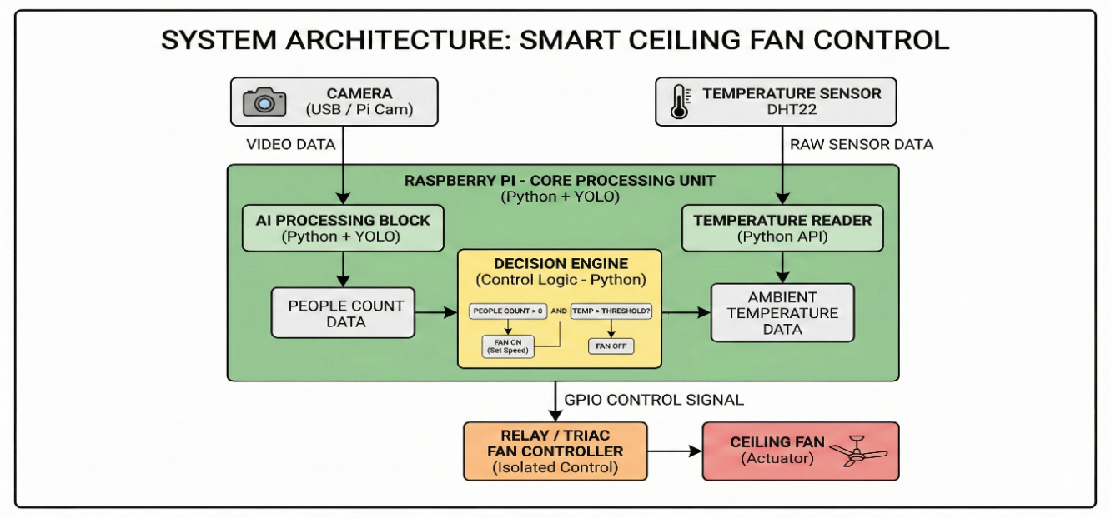

Hardware Components

Component | Description
Raspberry Pi / Edge AI Device | Processes AI model and system logic
Camera Module | Captures live video for person detection
Temperature Sensor (DHT22) | Measures room temperature
Relay Module | Controls electrical power to fan
Ceiling Fan | Air circulation device
Power Supply | Provides required electrical power

Software Components

The system software is developed using Python and several AI and computer vision libraries. OpenCV handles video capture and visualization. The YOLO object detection model detects humans in the camera feed. The decision logic determines the correct fan speed based on detected occupancy and temperature conditions.

Control Logic

People Count | Temperature | Fan Speed
0 | Any | OFF
1 | <25°C | LOW
1 | 25–30°C | MEDIUM
>=2 | >30°C | HIGH

Raspberry Pi GPIO Connections

DHT22 Sensor  -------------  VCC → 3.3V  GND → GND  DATA → GPIO4 | Relay Module  -------------  VCC → 5V  GND → GND  IN → GPIO17 | Relay Output  -------------  AC Live → Relay COM  Relay NO → Fan Live  Neutral → Fan Neutral
⚠Important: AC mains must be handled carefully.

Advantages of the System

- Energy efficient operation
- Fully automatic environmental control
- Smart home automation integration
- Reduced electricity consumption
- Scalable for office and classroom environments

Project Code

import cv2
from ultralytics import YOLO
import RPi.GPIO as GPIO
import Adafruit_DHT
import time

# GPIO setup
RELAY = 17
GPIO.setmode(GPIO.BCM)
GPIO.setup(RELAY, GPIO.OUT)

# Temperature sensor
sensor = Adafruit_DHT.DHT22
pin = 4

# Load AI model
model = YOLO("yolov8n.pt")

cap = cv2.VideoCapture(0)

while True:

ret, frame = cap.read()

if not ret:
break

results = model(frame)

people = 0

for r in results:
for box in r.boxes:

cls = int(box.cls[0])

if cls == 0:

people += 1

x1,y1,x2,y2 = map(int, box.xyxy[0])

cv2.rectangle(frame,(x1,y1),(x2,y2),(0,255,0),2)

humidity, temperature = Adafruit_DHT.read_retry(sensor, pin)

# Decision Logic

if people == 0:
fan_speed = "OFF"
GPIO.output(RELAY, GPIO.LOW)

else:

if temperature < 25:
fan_speed = "LOW"

elif temperature < 30:
fan_speed = "MEDIUM"

else:
fan_speed = "HIGH"

GPIO.output(RELAY, GPIO.HIGH)

# Display info
cv2.putText(frame,f"People: {people}",(20,40),
cv2.FONT_HERSHEY_SIMPLEX,1,(0,255,255),2)

cv2.putText(frame,f"Temp: {temperature:.1f}C",(20,80),
cv2.FONT_HERSHEY_SIMPLEX,1,(255,255,0),2)

cv2.putText(frame,f"Fan: {fan_speed}",(20,120),
cv2.FONT_HERSHEY_SIMPLEX,1,(0,255,0),2)

cv2.imshow("AI Smart Fan Prototype",frame)

if cv2.waitKey(1) == 27:
break

cap.release()
cv2.destroyAllWindows()
GPIO.cleanup()

Python Implementation for AI Smart Fan Control
Description

This Python program implements the core logic of the AI Smart Ceiling Fan System. The system uses a webcam to detect the number of people present in a room using the YOLOv8 object detection model. Based on the detected number of occupants and the room temperature, the program automatically determines the appropriate fan speed.
The system follows these steps:

- The camera captures real-time video from the room.
- The YOLOv8 deep learning model processes each frame and detects people.
- The number of detected people is counted.
- The system applies the decision logic to determine the fan speed.
- The results are displayed on the screen including the number of people and the fan speed.

This implementation demonstrates the integration of Artificial Intelligence, Computer Vision, and Smart Home Automation to create an intelligent fan control system.

Software Development Environment Development

Tool: Visual Studio Code (VS Code)
Programming Language: Python 3.10+

Libraries Used:

Library | Purpose
OpenCV (cv2) | Webcam access and image processing
Ultralytics YOLOv8 | AI-based person detection
Time | FPS calculation
Python Standard Libraries | Data logging and system control

Python Code

from ultralytics import YOLO
import cv2
import time

# Load YOLO model
model = YOLO("yolov8n.pt")
model.to("cpu")

# Open webcam
cap = cv2.VideoCapture(0)

temperature = 28
prev_time = 0

while True:

ret, frame = cap.read()

if not ret:
break

# AI detection
results = model(frame, device="cpu")

people = 0

for r in results:
for box in r.boxes:

cls = int(box.cls[0])

if cls == 0: # person class
people += 1

x1, y1, x2, y2 = map(int, box.xyxy[0])

cv2.rectangle(frame,(x1,y1),(x2,y2),(0,255,0),2)

cv2.putText(frame,"Person",(x1,y1-10),
cv2.FONT_HERSHEY_SIMPLEX,0.7,(0,255,0),2)

# -----------------------
# Smart Fan Logic
# -----------------------

if people == 0:
fan_speed = "OFF"
else:
if temperature < 25:
fan_speed = "LOW"
elif temperature < 30:
fan_speed = "MEDIUM"
else:
fan_speed = "HIGH"

if people >= 3:
fan_speed = "HIGH"

# -----------------------
# Power Consumption
# -----------------------

if fan_speed == "OFF":
power = 0
elif fan_speed == "LOW":
power = 25
elif fan_speed == "MEDIUM":
power = 45
else:
power = 70

# -----------------------
# FPS Calculation
# -----------------------

current_time = time.time()
fps = 1/(current_time-prev_time) if prev_time != 0 else 0
prev_time = current_time

# -----------------------
# Dashboard Panel
# -----------------------

cv2.rectangle(frame,(10,10),(380,220),(255,255,255),-1)

font = cv2.FONT_HERSHEY_SIMPLEX

cv2.putText(frame,f"People: {people}",(20,50),
font,1.1,(0,0,0),3)

cv2.putText(frame,f"Temp: {temperature} C",(20,90),
font,1.1,(0,0,0),3)

cv2.putText(frame,f"Fan Speed: {fan_speed}",(20,130),
font,1.1,(0,0,0),3)

cv2.putText(frame,f"Power: {power} W",(20,170),
font,1,(0,0,0),2)

cv2.putText(frame,f"FPS: {int(fps)}",(20,200),
font,0.8,(0,0,0),2)

cv2.putText(frame,
"Developed By Aluvala Ediga Harsha Vardhan Goud, MCA",
(10, frame.shape[0] - 10),
cv2.FONT_HERSHEY_SIMPLEX,
0.5,
(255,255,255),
1)

# -----------------------
# Log Data
# -----------------------

with open("fan_log.txt","a") as log:
log.write(f"People:{people}, Temp:{temperature}, Fan:{fan_speed}, Power:{power}\n")

# -----------------------
# Show window
# -----------------------

cv2.imshow("AI Smart Fan Camera",frame)

key = cv2.waitKey(1)

if key == 27:
break

if key == ord('u'):
temperature += 1

if key == ord('d'):
temperature -= 1

cap.release()
cv2.destroyAllWindows()

Software Implementation

The software component of the AI Smart Ceiling Fan System is implemented using Python along with computer vision and deep learning libraries. The system uses the YOLOv8 object detection model to detect the number of people present in a room through a webcam. Based on the detected occupancy and temperature conditions, the software automatically determines the appropriate fan speed.

The software performs the following operations:
- Camera Initialization – The system accesses the webcam using OpenCV to capture real-time video frames.
- AI-Based Human Detection – Each frame is processed by the YOLOv8 deep learning model to detect human objects.
- People Counting – The program counts the number of detected persons in the frame.
- Decision Logic Execution – The system determines the fan speed (OFF, LOW, MEDIUM, HIGH) depending on:
  - Number of people in the room
  - Room temperature
- Power Consumption Estimation – The estimated power consumption is calculated based on the fan speed.
- Real-Time Dashboard Display – The system overlays a dashboard panel displaying the number of people, temperature, fan speed, power usage, and FPS.
- Data Logging – System readings are saved into a log file (fan_log.txt) for future analysis.
- User Interaction – The temperature can be adjusted using keyboard controls:
  - U key → Increase temperature
  - D key → Decrease temperature

This software demonstrates the integration of Artificial Intelligence, Computer Vision, and Smart Home Automation technologies to develop an intelligent fan control system.

Algorithm Used

- Start system
- Initialize webcam
- Load YOLOv8 object detection model
- Capture video frame
- Detect people in frame
- Count number of detected persons
- Read temperature value
- Apply decision rules
  - No person → Fan OFF
  - 1 person → LOW speed
  - 2 persons → MEDIUM speed
  - 3 or more persons → HIGH speed
- Display system information
- Log system data
- Repeat process

Future Enhancements

- Integration with mobile applications
- IoT cloud monitoring and analytics
- Adaptive airflow optimization using machine learning
- Integration with smart building systems

Screenshot
